**Name:** Wasu Sonthichai

**Student ID:** 6238193221

1.

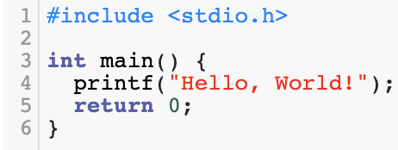

2.

3.

4.

5.

6.

7.

8.

9.

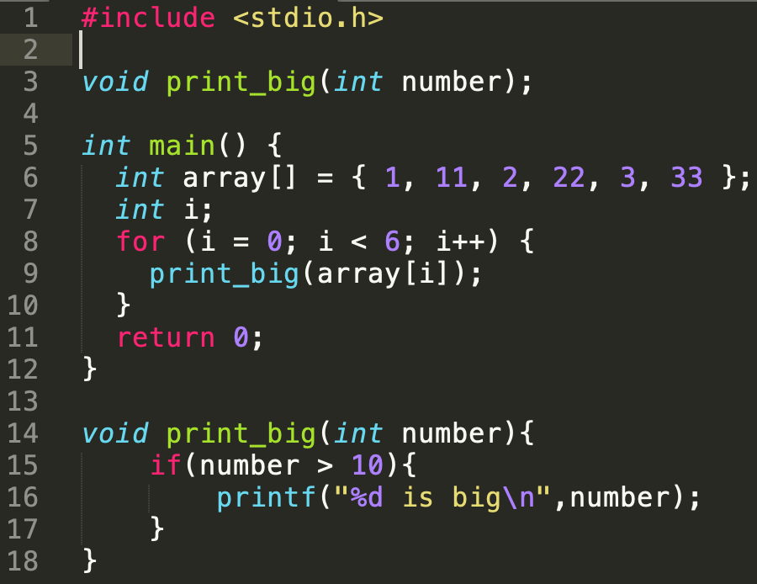

10.

